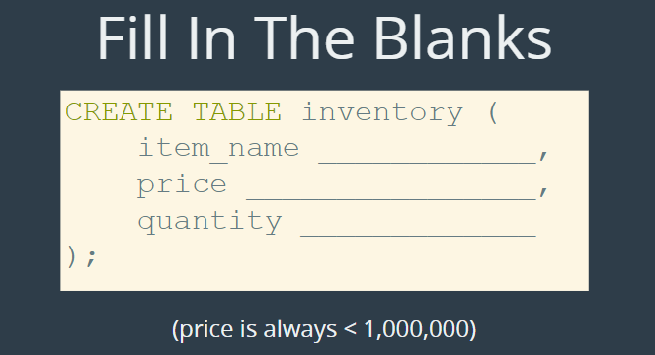











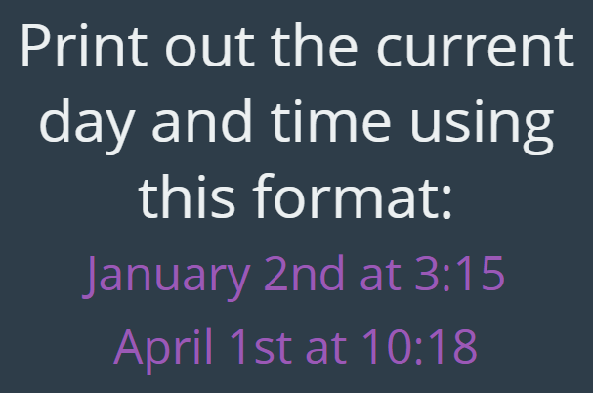



**The solutions:**

CREATE TABLE inventory (

item_name varchar(100),

price decimal(8,2),

quantity int

);

desc inventory;

select curtime();

select curdate();

select dayofweek(curdate());

select dayofweek(now());

select date_format(now(), '%w') + 1;

select dayname(now());

select date_fromat(now(), '%W');

select date_format(curdate(), '%m/%d/%Y');

select date_format(now(), '%M %D at %k:%i');

create table tweets(

content varchar(140),

username varchar(20),

created_at timestamp default now()

);

insert into tweets (content, username) values('this is my first tweet', 'coltscat');

select * from tweets;

insert into tweets (content, username) values('this is my second tweet', 'coltscat');

select * from tweets;